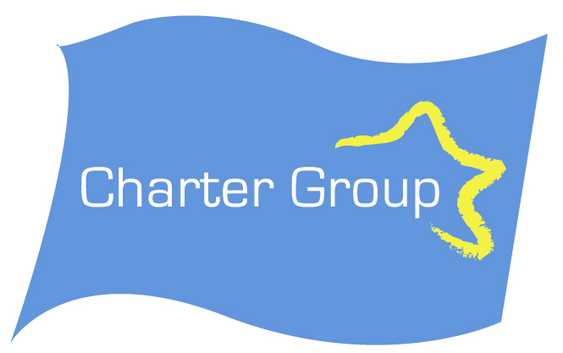Media Release

The Charter Group claims that the Charter of Fundamental Rights is an essential starting point to address concerns about ECJ decisions.

Blair Horan Secretary of the Charter Group said today that “without the Lisbon Treaty and the Charter as primary EU law the status quo on the European Court decisions remains. Nobody concerned about workers’ rights on the NO side has explained how rejecting the Treaty could improve workers rights”, he said.
It is important to emphasise that the European Court in the Viking case had approve strike action even though it restricted the freedom to establish a business in another member state. The Ruffert and Luxembourg judgments are about technical issues that have no implications in Ireland.
In the Laval case two points are important in an Irish context,
1 The Posting of Workers Directive was not implemented in Sweden to cover Construction pay rates. That is not the case in Ireland. The Construction industry Registered Agreement and pay rates are legally binding in Ireland.
2. One of the reasons that the strike was illegal was because in Sweden strikes are prohibited once a collective agreement is in place. The Latvian Trade Union had concluded a collective agreement on behalf of the posted workers.
All the Trade Union centres in the countries affected support Lisbon and consider the Charter an important step to address concerns they have about the decisions.
In Ireland the main industries likely to be affected by posted workers are covered by Registered Employment Agreements and therefore have trade union negotiated pay rates fully protected.
The European Court has already decided that competition policy can be restricted by collective bargaining (Case C 67/96 Albany paragraph 59)
The Court is more stringent in relation to the 4 Treaty freedoms (movement of labour, goods, services and capital). It allowed strike action in Viking. It disallowed it in Laval but primarily due to Sweden’s failure to properly implement the Posting of Workers’ Directive. However the Advocate General would have allowed the strike, so the issues were finely balanced. The Charter if Lisbon is ratified will have equal status to the treaty freedoms and we believe that gives the potential to tip the balance.
The No campaign has no constructive proposals on workers’ rights except to tear up the Treaty and plunge Europe into crises.
- They selectively quote from a case about a milk quota dispute to wrongly suggest that the market prevails leaving out the reference that the essence of the rights must be respected.
- Some of them (Joe Higgins MEP) have rewritten Charter Article 52 to make it suit their arguments. This is very evident in the manner that Article 52 in the Charter agreed at Nice in 2000 was altered to change its meaning. See Press Release of yesterday available on our website at www.thechartergroup.ie . Article 52 of the 2007 Charter attached to the Lisbon Treaty is reworded but the meaning is exactly the same as in the original. It is difficult to believe that this could be just an error. The manner in which the Article is reworded by Mr Higgins is deliberately done to completely change its meaning. This is not a case of using a wrong version of an Article.
- They confuse competition policy in Article 81 and the Treaty freedoms, in Article 39 for Workers, and Article 49 on Services. Fundamental rights such as collective bargaining can already restrict competition, and strike action can prevent the right of establishment under Article 43.The Charter will now give full Treaty status to Workers’ Rights

Contact Blair Horan 087 2561888

Note for editors
The correct interpretation of Article 52 paragraph 2 in both its 2000 and 2007 versions is that Charter Articles that come directly from the Treaty have the same meaning as the Treaty. An example is Treaty Article 16 on public services which is Charter Article 36.
Mr Higgins by altering the 2000 version of Article 52 changes the meaning completely so that it reads that all Charter Articles are limited by the Treaty(in this case the market , competition policy Article 81 or the right to establish a business Article 43)
See our website for both 2000 (Press Release) and 2007 (Main Documents) versions of the Charter.

